Skoolz Out Summer Holiday Programme Week One
£25 per day or £100 for 5 days. Opening hours 8am - 6pm
 |  |  | Thurs 27th June | Friday 28th June
 |  | Can we remind parents of children attending Skoolz Out during the holidays, a pack lunch is required. Please can you provide your child/children with at least 2 drinks for throughout the day (No fizzy drinks). If you require your child to be picked up early please inform a member of staff.  Outings will go ahead regardless of the weather if you can make sure your child/children are appropriately dressed. Can we ask that you please supply your child/children with sun cream. | I.C.T Playstation 4, Nintendo Switch, Board Games  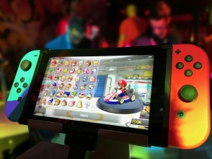 | Gym Hall, Football,  Free Play  
 |  |  | Outdoor Play, Arts & Crafts   | Badminton, Tennis,  Free Play  

Skoolz Out Summer Holiday Programme Week Two
£25 per day or £100 for 5 days. Opening hours 8am - 6pm

Monday 1st July | Tues 2nd July | Wed 3rd July | Thurs 4th July | Friday 5th July
Ayr adventure Playground   | Free Play  Arts & Crafts  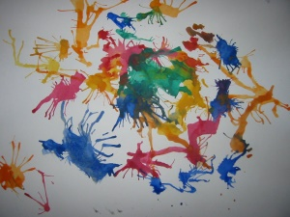 | Loch Lomond  Shores  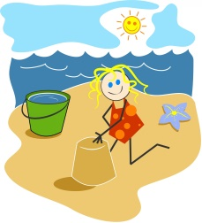 | Outdoor Play,  Free Play,  | 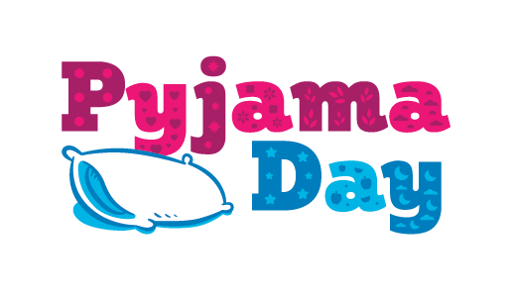
Free Play   | Dance   | Free Play | Gym Hall, Bench Ball,  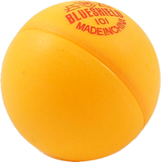 | Popcorn  

Skoolz Out Summer Holiday Programme Week Three
£25 per day for £100 or 5 days. Opening hours 8am - 6pm

Monday 8th July | Tues 9th July | Wed 10th July | Thurs 11th July | Friday 12th July
Outdoor Play,  Free Play, | Bellahouston Park  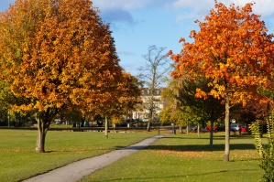 | Painting, Board Games, 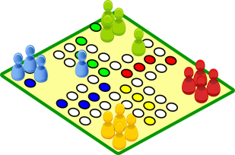 | Local Park  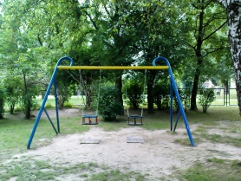 | Gym Hall  Obstacle Course  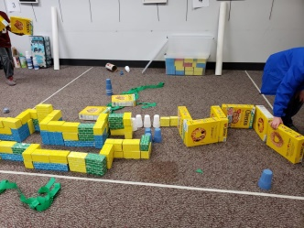
Arts & Crafts   | I.C.T, Nintendo Switch PS4   | Free Play | Decorating Cakes,  Role Play   | Talent Show  

Skoolz Out Summer Holiday Programme Week Four
£25 per day for £100 or 5 days. Opening hours 8am - 6pm

Monday 15th July | Tues 16th July | Wed 17th July | Thurs 18th July | Friday 19th July
Closed  Glasgow Fair Monday | Eyes down Bingo  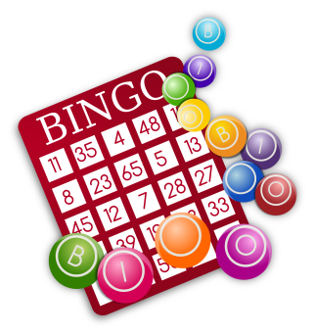 | Largs Adventure playground  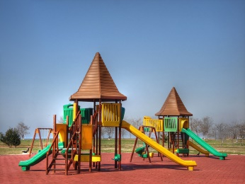 | Outdoor Play   | I Pad, Nintendo Switch, PS4  
 | Lego Competition  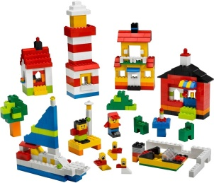 | Free Play | DVD  Jenga, Board Games  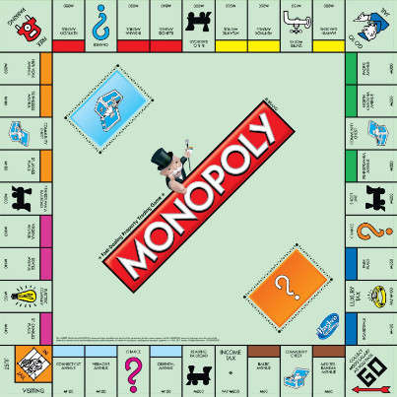 | Tennis, Swing Ball, Archery  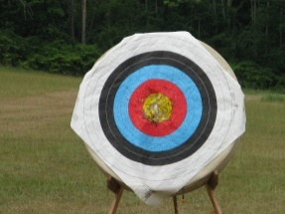

Skoolz Out Summer Holiday Programme Week Five
£25 per day for £100 or 5 days. Opening hours 8am - 6pm

Monday 22nd July | Tues 23rd July | Wed 24th July | Thurs 25th July | Friday 26th July
Outdoor Play  Tennis, Football, Badminton   | Cinema   | Arts & Crafts   | Barshaw Park  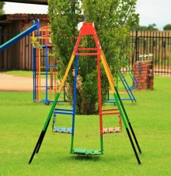 | I.C.T  Nintendo Switch  I Pad  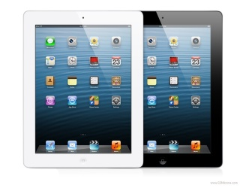
Gym Hall  Basketball   | Free Play | Board Games  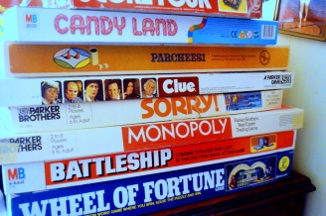 | Free Play | DVD  Popcorn  

Skoolz Out Summer Holiday Programme Week Six
£25 per day for £100 or 5 days. Opening hours 8am - 6pm

Monday 29th July | Tues 30th July | Wed 31st July | Thurs 1st August | Friday 2nd August
Rouken Glen Park  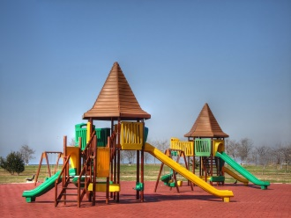 | Arts & Crafts   | The Helix  Adventure Play Park Falkirk  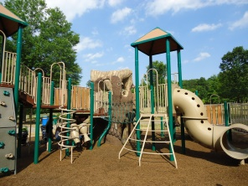 | Cake Decorating  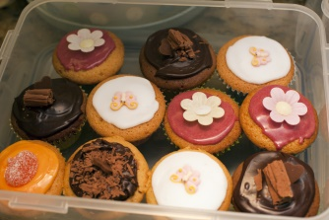 | Science Experiment  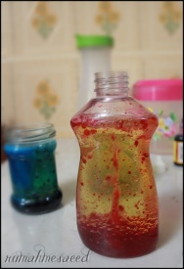
Free Play | Outdoor Play  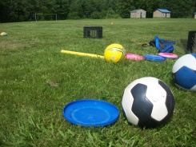 | Free Play | PS4, Nintendo Switch   | Gym Hall  Obstacle Course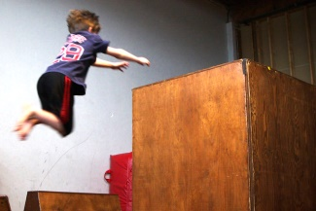

Skoolz Out Summer Holiday Programme Week Seven
£25 per day for £100 or 5 days. Opening hours 8am - 6pm

Monday 5th August | Tues 6th August | Wed 7th August | Thurs 8th August | Friday 9th August
Science Week Experiments   | Saltcoats Beach  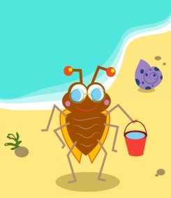 | Science Week Experiments  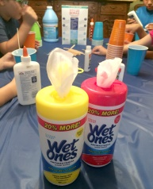 | Prestwick Play Park  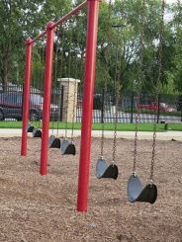 | Science Week Experiments

Skoolz Out Summer Holiday Programme Week Eight
£25 per day for £100 or 5 days. Opening hours 8am - 6pm

Monday 12th August | Tues 13th August | Wed 14th August
Free Play | Board Games, I.C.T, Arts & Crafts  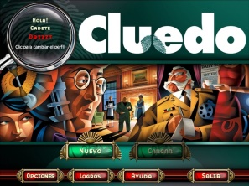 | Back to School
Gym Hall  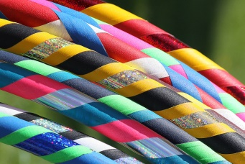 | DVD  

